**Capstone Project**

**Movie Review Simulator – Solution Document**

**Full Stack Application using Spring Boot and Angular**

**Objective:** Create a Movie Review Simulator application using Spring Boot and Mysql for backend and Angular for frontend.

**Tools required:** STS, Mysql, Visual Studio Code, Node.js

**Prerequisites:** Install Java (Java 8 recommended), STS, Visual Studio Code, Node.js

**Steps to be followed:**

1. Open STS
2. Import code into Eclipse using the **Import Maven Project** option
3. Clone the project repo from https://github.com/MaheshShittlani/MovieTicketBookingSimulator.git
4. Complete the set-up process that has been explained in the **readme.txt** file
5. Run **App.java** as a Java application in STS

**Step 1:** **Open STS**

# **1.1** Open the previously installed version of STS

**Step 2:** **Import maven project into Eclipse using the Import Maven Project option**

**2.1 Select the root folder of the project.**

**2.2 Then, select finish.**

**2.3 You should see the exiting code in the project as follows**

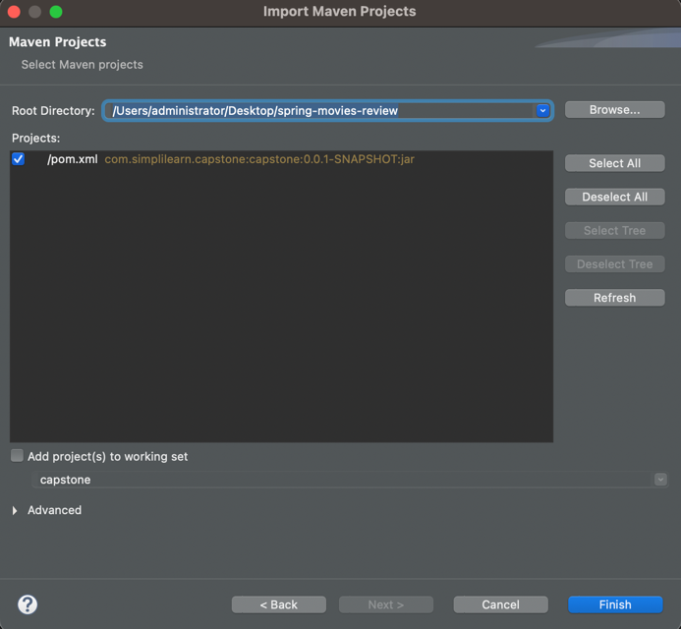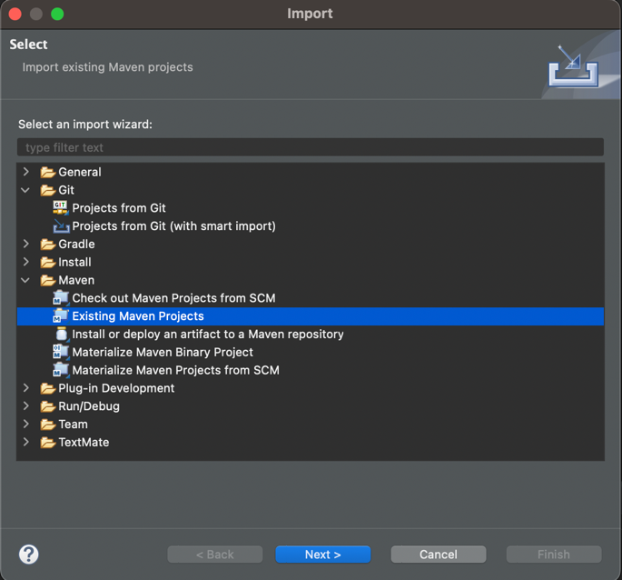

**Step 3: Run the application**

**3.1 Open MovieReviewsAppApplication.java**

**3.2 Right Click > Run As > Spring Boot Project**

# **3.3 You should see the following in the console**

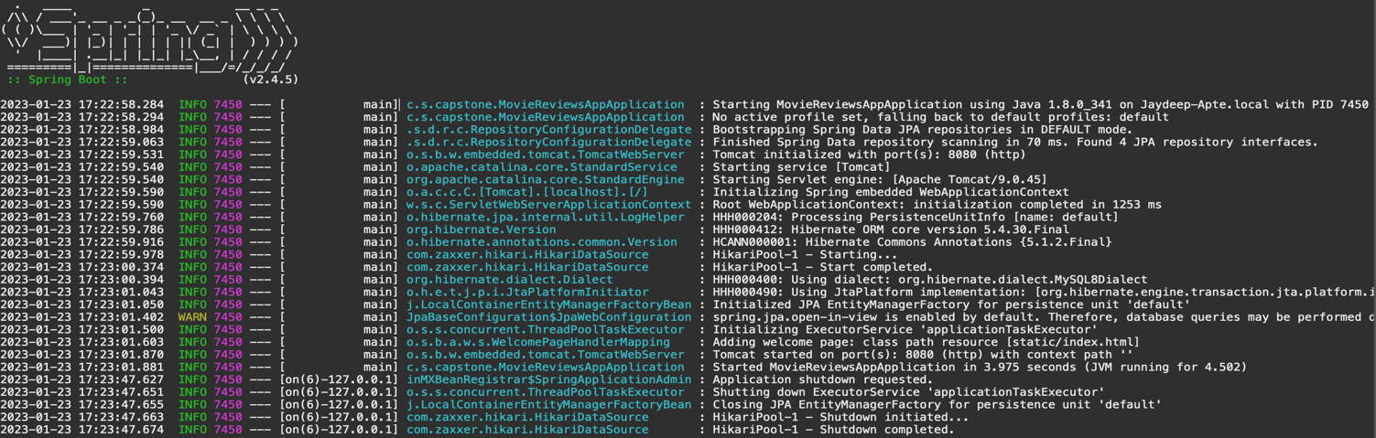

**Step 4:** **Open Postman Tool**

**4.1 Try to add a new user by adding appropriate user JSON object and correct Spring Web API REST Endpoint.**

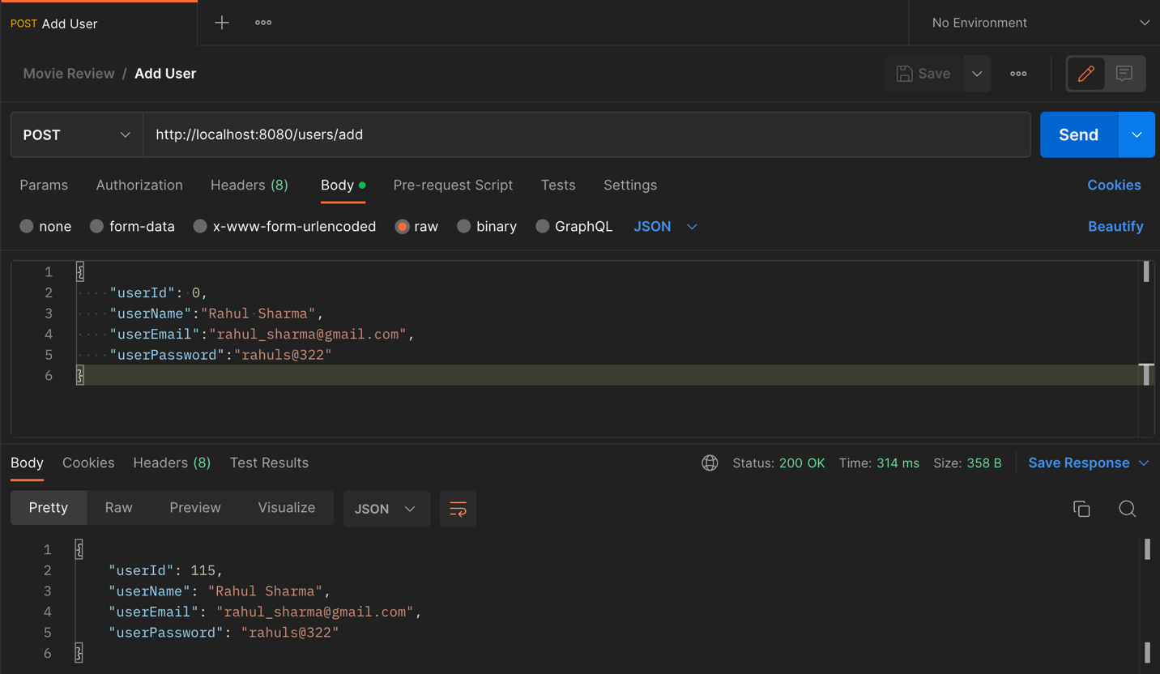

4.2 Similarly, test all the REST API Endpoints by opening each Controller classes in the project.